Spring Data JPA - Quick Example
Submitted by: Rishi Gupta

Objective
The goal of this exercise was to build a small Spring Boot application that connects to a MySQL database using Spring Data JPA and Hibernate, and to fetch records from a table using a repository and service layer. This document walks through what was done and the issues I ran into along the way.

Environment Setup
Before starting the actual exercise, I had to get Eclipse working properly on my system. My project initially had an unbound JRE, so I installed and pointed Eclipse to my local JDK (Java 17) through Window > Preferences > Java > Installed JREs, and then fixed the project's Build Path so it used that JDK. Once that was resolved, the project stopped throwing build errors and I could compile and run Java classes normally.

Project Creation
I generated a new Spring Boot project using Spring Initializr with the group ID com.cognizant and artifact ID orm-learn, and added the Spring Boot DevTools, Spring Data JPA, and MySQL Driver dependencies. The generated project was extracted and imported into Eclipse as an existing Maven project.

Database Setup
Using MySQL Workbench, I created a new schema called ormlearn and a table named country with two columns, co_code (primary key) and co_name. I then inserted two sample rows into the table — IN/India and US/United States of America — so there would be data to query once the application was running.

Application Code
Inside the project, I created the following packages and classes under com.cognizant.ormlearn:
- Country.java (model) — an @Entity class mapped to the country table, with fields for code and name mapped to the co_code and co_name columns respectively.
- CountryRepository.java (repository) — an interface extending JpaRepository<Country, String> to provide built-in CRUD operations.
- CountryService.java (service) — a @Service class that autowires the repository and exposes a getAllCountries() method annotated with @Transactional.
- OrmLearnApplication.java — the main class, updated to fetch the CountryService bean from the application context after startup and log the retrieved list of countries.
I also updated application.properties with the database URL, credentials, and logging configuration so that Hibernate would print the SQL statements it executes.

Issues Faced and Fixes
Since the Spring Boot version generated by Initializr (4.1.0) was much newer than the one referenced in the original instructions, I ran into a few version-related issues that had to be worked through one at a time:
- The Hibernate dialect class mentioned in the reference material (MySQL5Dialect / MySQL8Dialect) no longer exists in the newer Hibernate version, so I removed the dialect property entirely and let Hibernate auto-detect it.
- The database connection initially failed with an access-denied error, which turned out to be an incorrect password in application.properties — fixed by updating it to match the actual MySQL root password.
- Spring Boot did not automatically detect my service, repository, and entity classes because my main application class was in a different base package. I resolved this by setting scanBasePackages on @SpringBootApplication and explicitly configuring @EntityScan and @EnableJpaRepositories to point to the correct packages.
- The @EntityScan annotation had moved to a new package in this Spring Boot version, so I updated the import accordingly.
- Finally, the query failed with an "unknown column" error because my entity was mapped to code and name while the actual table columns were co_code and co_name. Updating the @Column annotations to match the real column names fixed this.

Result
After resolving the above issues, the application started successfully, connected to the ormlearn database, executed the generated SQL query, and printed both country records (India and United States of America) to the console log before shutting down cleanly. This confirmed that the Spring Boot application, Spring Data JPA repository, and Hibernate ORM mapping were all working correctly end to end.

Screenshots
Below is the Eclipse console output showing the application starting up, connecting to MySQL, and running the query.
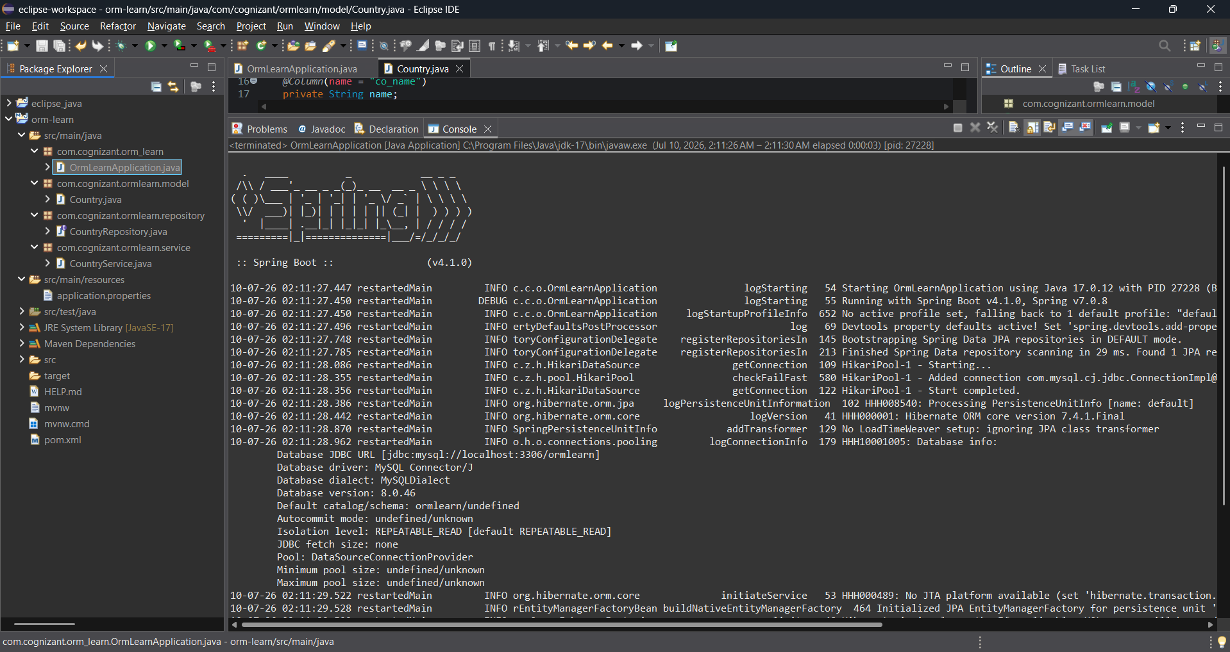
Full console log confirming successful retrieval of both country records and clean application shutdown.
